# Test Design

**Test Scenarios & Test Cases**

**=> In Design phase Test Engineer identify test scenarios.**

**=> For Identified Test scenarios Testers design test cases.**

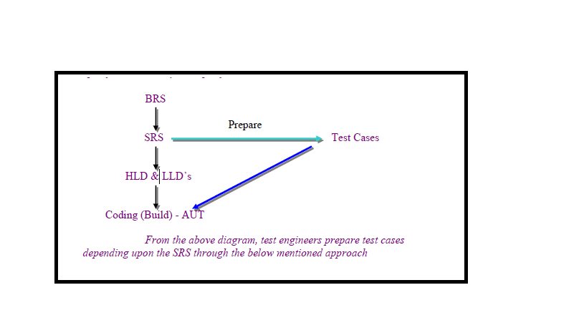

**Test Scenario**

* Possible areas to be tested
* In Agile testing Scenario defines what to test in user story
* In general test scenarios listed in Test Plan or Release plan document
* Test scenarios identified by the Test lead or Sr. Test Engineer.
* Scenarios are useful to track test cases
* **Entry Criteria for identifying test Scenarios:**
* Approved Test Plan or Release Plan
* Approved SRS or use case document
* Test Scenario template [IEEE 829 ]
* Any design documents available (if any)
* Any blueprints available (if any)

**Exit Criteria for test Scenarios:**

* Test scenarios Should reviewed & Approved.
* Once test Scenarios are approved test lead will create a baseline for test Scenarios (TS1.0v) and update the scenarios into Common Repository.

Test scenario template:🡪

|  |  |  |  |  |  |
| --- | --- | --- | --- | --- | --- |
| Scenario ID | Scenario Name | Child scenarios [if any] | Description | Test case count | Development Status |
| Ts1.0 | Browser catalog |  | User can access every page from menu tabs | 2 | Done |
| Ts2.0 | Search Product | Clear  High to Low  Low to High | User can search with valid product name | 3 | NA |
| Ts3.0 | Compare product |  | User can compare products before buying | 4 | In Progress |
| Ts4.0 | Add to Cart | New Arrivals  Coming Soon  Out of stock | User can add list of products to cart | 3 | Done |
| Ts5.0 | Add Billing address |  | User can enter billing address | 2 | Done |

Scenarios in Agile:🡪[BDD template]🡪 Behavior development driven template🡪

|  |  |  |  |
| --- | --- | --- | --- |
| EPIC | DESCRIPTION | USER STORY | SCENARIO |
| Product Search | User able to search available products with product name or product specifications | As a User  I Can Search Product | Given site URL is http://flipkart.com When Enter product name at search edit box And click on Search Button Then All Related Product should be displayed |
|  |  |  | Given product specification at search edit box And click on Search button Then display related products |
|  |  |  | Given Product name When user click on Clear button Then Search will be clear |
|  |  |  | Given Product name and click on search When user click on Low-to-High button Then Products display in Low to High range |

**What is a Test Case.?**

* A test case is set of user actions and sub sequent response from the system
* Every positive and negative action at software what sub sequent response receive from system we design as Test-case steps.
* Test case determines what to be tested, what action to be done, what data to be provided in order to check software response meeting with client expectation.
* Here tester prepare test cases as checklist based on client requirement when software is under development, Once software is ready tester use same checklist to verify is software developed as client expected.

**Entry Criteria to prepare test cases:**

* Approved Test Plan / Release plan
* Approved SRS
* Approved **FRS** [or] Use case template[Use case template is ideal way to design test cases]
* Approved Test Scenarios
* Test Case template
* KT on user requirement [Knowledge Transfer]

**Exit Criteria for test cases:**

* Test Cases should be reviewed & Approved.

**Test Case contains**

A test case should contain particulars such as:

* Objective
* Test Conditions
* Input data
* Expected results
* Location of the files to be used in Test Case [Test scenario reference numbers, Document Reference numbers]
* Trouble shooting guidelines

**Good Test Case Design**

A good test case satisfies the following criteria

* Effective – Finds Faults (Objective)
* Evaluable – Easy to maintain
* Requirement Completeness
* Easy to understand
* Should not be out of scope - do not contain un necessary things
* Don’t predict stick to documentation
* Test cases should write in uniform way. [If you started test cases for one requirement don’t merge other requirement ]

***Test Case Design Techniques***

**Test Case design techniques can be broadly categorized into 2:**

* Black Box (Functional) Test case design Techniques
* White Box (Structural) Test case design Techniques
* Experience Testing [Informal testing]

**Black Box Test case design Techniques:**

* Equivalent class Partitioning [ECP]
* Boundary value Analysis [BVA]
* Decision table [DT]
* State transition technique
* Error guessing

***Why test techniques***

* Exhaustive testing (Use of all possible inputs and conditions) is impractical.
* Need thought processes that help us to select test cases more intelligently
* Test case design techniques helps to cover more areas to test software.
* Possible to test hidden areas

**Advantages of techniques**

* Different people: Similar probability of finding faults
* Effective testing: to find more deviations (faults)
* One can focus or pay more attention on specific types of faults
* To know you are testing right thing.
* Avoid duplications
* Identify the best possible combinations to cover maximum conditions

**Equivalence Partitioning**

* Equivalence partitioning is a method for deriving test cases

In this method given input is divided into number of equivalence classes.

* From each equivalence class one input value is choose for testing.
* Equivalent partitioning drastically cuts down the number of test cases
* We can Label the ECP Classes as “Valid” and Invalid”

**Example:**

Consider any edit field which can accept values b/w 4-12.

From the given range of i/p value we can form 3 equivalence classes.

     i) Less than 4.

   ii) Between 4 -12.

  iii) Greater than 12.

* Consider edit field accept only Alphabets
  + Valid :🡪 Alphabets [a-z][A_Z]
  + Invalid:🡪Numerics, Special Characters, Spaces, Blank

Consider edit field accept only Alphabets and Numerics, At least One Numeric value

* + Valid:🡪 Alphabets[a-z] + Numeric [1], Alphabets[a-z]+numeric[1+]
  + Invalid:🡪 only Numeric, Only Alphabets, Special Characters, Spaces, Blank
* Consider edit fields accept alphabets, Should starts with uppercase and should contains at least one special characters..

Valid:🡪 Alphabets starts with uppercase and include one special character

Alphabets starts with uppercase and include more than one special character

Invalid:🡪

Alphabets Starts with lowercase,

Alphabets without special character,

Numbers,

Spaces,

Starts with Numbers,

Starts with special characters,

Start with space.

|  |  |  |
| --- | --- | --- |
| **User Name** | **Role** | **Rights** |
| Abhay | Financial Prof. | Assign |
| Sriram | Customer | View, Add, Update |
| Ravi | Customer | View, Add, Update |
| Dinakar | Financial Prof. | Assign |
| Bhaskar | Employee | View, Delete, Add, Update |
| Ramya | Financial Prof. | Assign |
| Pranathi | Financial Prof. | Assign |
| Harsha | Employee | View, Delete, Add, Update |
| Suchitra | Agent | View |

* Identify similar functionalities and divide equally
* Divide the inputs, outputs, etc., into areas which are same
* Here the assumption is, if one value works then all should work
* Identify one from each partition instead of all from one

|  |  |  |
| --- | --- | --- |
| **Role** | **User Name** | **Rights** |
| Financial Prof. | Abhay | Assign |
| Customer | Sriram | View, Add, Update |
| Employee | Bhaskar | View, Delete, Add, Update |
| Agent | Suchitra | View |

**Example:**

Specifications state that a max of 4 purchase orders can be registered against any one product:

The equivalence classes are:

Valid Class: 1 – 4 Purchase Orders

Invalid Classes: # Purchase Orders > 4, # Purchase Orders < 1

**Boundary Value Analysis**

* In this method tester has to concentrate more on the boundaries of the input values.
* In testing boundary conditions have a higher probability of detecting errors.
* Here tester verify the faults at near boundaries
* It is a sub technique for ECP technique..

**Example:**

* Consider any edit field which can accept values b/w 18-35.
* According to BVA method the valid inputs are:
* 17,18,….35 & 36
* If the range is 'a' to 'b'
* Then valid inputs are:  a-1, a, a+1, b-1, b, &b+1

**Example:🡪**

**Consider Zip code edit box accept Max number 6 only.**

**According to BVA testable boundaries are**

* **Max, Max+1, Max-1**
* **6,7,5**

**Example**

* Program Accepts 1 To 100 Characters and identify Boundary values
* The valid inputs are:  a-1, a, a+1, b-1, b, & b+1
* 0, 1 to 100, 101

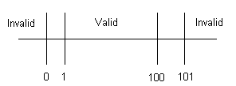

**Example:**

* Customer Name – 2 to 64 Chars
* Account Number – 6 digits, first digit is non zero
* Loan Amt requested – $500 to $ 9000
* Loan Term – 1 to 30 years
* Monthly Repayment – Min of $ 10

**Customer Name**

|  |  |  |  |  |
| --- | --- | --- | --- | --- |
| **Conditions** | **Valid Partitions** | **Invalid Partitions** | **Valid Boundaries** | **Invalid Boundaries** |
| Customer Name | 2 to 64 chars valid Chars | < 2 Chars  > 64 Chars  Invalid Chars | 2 Chars  64 Chars | 1 Char  65 Chars  0 Chars |

**Account Number**

|  |  |  |  |  |
| --- | --- | --- | --- | --- |
| **Conditions** | **Valid Partitions** | **Invalid Partitions** | **Valid Boundaries** | **Invalid Boundaries** |
| Account Number | 6 digits  1st non-zero | < 6 digits  > 6 digits  1st digit = 0  Non-digit | 100000  999999 | 5 digits  7 digits  0 digits |

**Loan Amount**

|  |  |  |  |  |
| --- | --- | --- | --- | --- |
| **Conditions** | **Valid Partitions** | **Invalid Partitions** | **Valid Boundaries** | **Invalid Boundaries** |
| Loan Amount | 500-9000 | < 500  > 9000  0  Non-numeric | 500  9000 | 499  9001 |

Decision Table:🡪

* Decision Table:
  + A table showing combinations of inputs and outputs which can be used to design the test cases.
  + This technique is also referred as *cause-effect* table.

Decision Table for Gmail Login Test:🡪

Use case:🡪

* User should enter valid username
* User should enter valid password to login
* Password allowed after email validation only

|  |  |  |  |  |
| --- | --- | --- | --- | --- |
|  | Rule 1 | Rule 2 | Rule 3 | Rule 4 |
| **Conditions** | | | | |
| Valid User Name | **False** | **True** | **True** | True |
| Valid Password | **-** | **False** | **True** | - |
| **Actions** | | | | |
| Login accepted | **False** | **False** | **True** | False |

Decision Table for Face book Login:🡪

* User should enter valid username
* User should enter valid password to login
* No Restriction of password entry

|  |  |  |  |  |  |  |  |
| --- | --- | --- | --- | --- | --- | --- | --- |
|  | Rule1 | Rule2 | Rule3 | Rule4 | Rule5 | Rule6 | Rule7 |
| **Conditions** | |  |  |  |  |  |  |
| Username Entry | True | False | False | - | True | - | True |
| Password Entry | False | True | False | true | - | - | True |
| **Actions** | |  |  |  |  |  |  |
| Login accepted | False | False | False | False | False | False | True |

Decision Table for Face book:🡪

* User can enter mobile number or email for login

|  |  |  |  |  |  |  |
| --- | --- | --- | --- | --- | --- | --- |
| Conditions |  | Rule 8 | Rule 9 | Rule 10 | Rule 11 | Rule 12 |
| Mobile |  | true | false | false | true | true |
| Password |  | false | true | false | - | true |
| Actions |  |  |  |  |  |  |
| Login accepted |  | false | false | false | false | true |